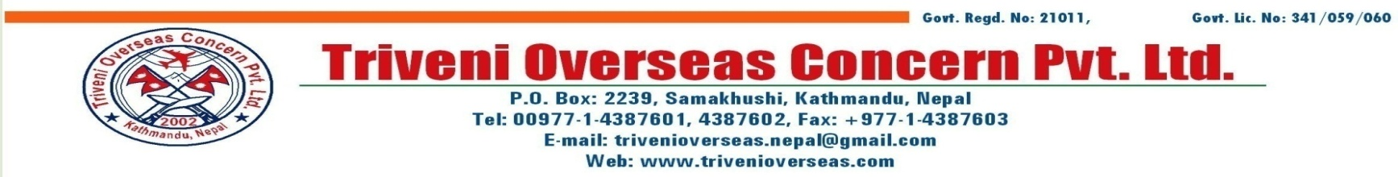  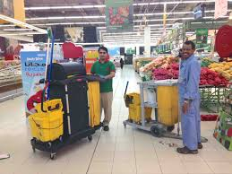

**(10Jan/2016)ID/111/LD**

**About Us:**

**Saudi** sf] lgDg sf**]** nflu lgDgpNn]lvt sfdbf/x?sf] dfueO{ cfPsfn] hfgrfxg] of]Uo g]kfnLgfu/Lsx?n] ;DalGwtsfdsf] cg'ejsf] k|df0f kq, ;Ssn /fxbfgL, z}lIfs of]Uotfsf] k|df0f kq, jfof]8f6f / /+uLglgnf] kbf{ ePsf] kf;kf]6{ ;fO{hsf] **)\*** k|ltxfn;fn} lvrfPsf] kmf]6f] ;lxt o; sfof{nodf t'?Gt ;Dks{ ug'{xf]nf .

|  |  |  |  |  |  |
| --- | --- | --- | --- | --- | --- |
| **S.N** | **CATEGORIES** | **QTY** | **SALARY (SR)** | **SALARY (NRS)** | **Note:-** |
| **1.** | **DRIVER HEAVY** | **15** | **1800 +200+OT** | **56000+OT** | MIN 3YEARS EXPERIENCE RELATED FILD AND MUST HAVE GCC LICENCE |
| **2.** | **CLEANER** | **40** | **750+Food+OT** | **30000+OT** | **Healthy , Strong & disciplined** |
| **3.** | **LABOUR** | **25** | **800+200 +OT** | **28000+OT** | **Healthy , Strong & disciplined** |

**TERMS AND CONDITIONS:-**

|  |  |  |  |  |
| --- | --- | --- | --- | --- |
| **Food** | **Accommodation** | **Contract Period** | **Duty Hours** | **Remarks** |
| **YES** | **Provided** | **After 2 Years return ticket provided by company)** | **8Hrs / 6days** | **000** |

Form Dress,Gloves& Shoes will be provided by company.

MOFA READY FOR MEDICAL….

**Cv Forward & selection by 'Triveni' representative**

Note: They shall be Age group 21 to 35 years only, Original Passport & 8 Pcs photo compulsory for appear Visa….

